# Supplemental Information

Supplementary Table 1. Fisher behavioral and demographic variables derived and used in the clustering and random forest analyses. Variables with asterisks were removed from the final clustering analysis due to high collinearity with other variables.

|  |  |  |
| --- | --- | --- |
| **Category** | **Variable** | **Definition** |
| **Port Use** | Ports per Trip | Average ports visited per trip |
| Ports per Month | Number of ports visited per month |
| Port Diversity | Shannon diversity index of port use across the entire season |
| Total Ports* | Total number of ports visited across the entire season |
| **Trip Length** | Mean Trip Distance* | Mean distance per fishing trip |
| Mean Trip Duration | Mean number of days per fishing trip |
| SD Trip Distance* | Standard deviation of distance traveled per trip |
| SD Trip Duration | Standard deviation of days per fishing trip |
| **Participation in Other Fisheries** | Season Length | Day-of-season on which fisher reached 90% of eventual, cumulative catch |
| Proportion Non-Dungeness Revenue | Proportion of revenue from non-Dungeness crab fisheries |
| Proportion Non-Dungeness Tickets* | Proportion of all fish tickets from non-Dungeness crab fisheries |
| Revenue Diversity | Inverse Simpson diversity index of revenue by fished species |
| **Risk-taking** | Risk Taking | Propensity to fish in high winds. Proportion of trip pursued where the 95% quantile of wind speed was greater than 7.5 m/s |
| **Exploration & Mobility** | Location Entropy | Cumulative choice entropy, measuring how likely a vessel is to fish in new versus past locations. The metric used is the 90th percentile of maximum choice entropy per vessel per season |
| Home Range Size | Home range defined as the area of the convex hull surrounding all of a vessel's VMS pings during the season, excluding the top 5% spatial outliers |

Supplementary Table 2. Tukey’s honest significant difference analysis on seasonal non-Dungeness crab revenue per vessel, corresponding to Figure 3b in the main text. MHW: marine heatwave period; Non-MHW: non-marine heatwave period. Bolded rows are within-behavioral-group, between-period comparisons. Of these within-group comparisons, differences with a p-value<0.05 are indicated with stars in Fig. 3b.

|  |  |  |  |  |  |
| --- | --- | --- | --- | --- | --- |
| **Group 1** | **Group 2** | **Difference** | **Lower** | **Upper** | **Adjusted p-value** |
| **MHW:Local Specialists** | **Non-MHW:Local Specialists** | **19014** | **-51710** | **89738** | **0.992** |
| Non-MHW:Local Generalists | Non-MHW:Local Specialists | 162616 | 114336 | 210897 | 0.000 |
| MHW:Local Generalists | Non-MHW:Local Specialists | 376497 | 311019 | 441974 | 0.000 |
| Non-MHW:Roving Specialists | Non-MHW:Local Specialists | 26136 | -27947 | 80219 | 0.826 |
| MHW:Roving Specialists | Non-MHW:Local Specialists | 83978 | 21786 | 146169 | 0.001 |
| Non-MHW:Roving Generalists | Non-MHW:Local Specialists | 408766 | 352788 | 464743 | 0.000 |
| MHW:Roving Generalists | Non-MHW:Local Specialists | 846315 | 773088 | 919542 | 0.000 |
| Non-MHW:Local Generalists | MHW:Local Specialists | 143602 | 80018 | 207187 | 0.000 |
| MHW:Local Generalists | MHW:Local Specialists | 357483 | 280027 | 434938 | 0.000 |
| Non-MHW:Roving Specialists | MHW:Local Specialists | 7122 | -60974 | 75217 | 1.000 |
| MHW:Roving Specialists | MHW:Local Specialists | 64964 | -9734 | 139662 | 0.143 |
| Non-MHW:Roving Generalists | MHW:Local Specialists | 389751 | 320141 | 459361 | 0.000 |
| MHW:Roving Generalists | MHW:Local Specialists | 827301 | 743193 | 911410 | 0.000 |
| **MHW:Local Generalists** | **Non-MHW:Local Generalists** | **213880** | **156187** | **271574** | **0.000** |
| Non-MHW:Roving Specialists | Non-MHW:Local Generalists | -136481 | -180822 | -92139 | 0.000 |
| MHW:Roving Specialists | Non-MHW:Local Generalists | -78639 | -132573 | -24704 | 0.000 |
| Non-MHW:Roving Generalists | Non-MHW:Local Generalists | 246149 | 199515 | 292783 | 0.000 |
| MHW:Roving Generalists | Non-MHW:Local Generalists | 683699 | 617341 | 750057 | 0.000 |
| Non-MHW:Roving Specialists | MHW:Local Generalists | -350361 | -412991 | -287731 | 0.000 |
| MHW:Roving Specialists | MHW:Local Generalists | -292519 | -362271 | -222768 | 0.000 |
| Non-MHW:Roving Generalists | MHW:Local Generalists | 32269 | -32004 | 96542 | 0.795 |
| MHW:Roving Generalists | MHW:Local Generalists | 469819 | 390071 | 549566 | 0.000 |
| **MHW:Roving Specialists** | **Non-MHW:Roving Specialists** | **57842** | **-1344** | **117027** | **0.061** |
| Non-MHW:Roving Generalists | Non-MHW:Roving Specialists | 382630 | 330012 | 435248 | 0.000 |
| MHW:Roving Generalists | Non-MHW:Roving Specialists | 820180 | 749488 | 890872 | 0.000 |
| Non-MHW:Roving Generalists | MHW:Roving Specialists | 324788 | 263866 | 385709 | 0.000 |
| MHW:Roving Generalists | MHW:Roving Specialists | 762338 | 685266 | 839410 | 0.000 |
| **MHW:Roving Generalists** | **Non-MHW:Roving Generalists** | **437550** | **365398** | **509702** | **0.000** |

Supplementary Table 3. Tukey’s honest significant difference analysis on seasonal home range size (in square km) per vessel, corresponding to Figure 4b in the main text. MHW: marine heatwave period; Non-MHW: non-marine heatwave period. Bolded rows are within-behavioral-group, between-period comparisons. Of these within-group comparisons, differences with a p-value<0.05 are indicated with stars in Fig. 4b.

|  |  |  |  |  |  |
| --- | --- | --- | --- | --- | --- |
| **Group 1** | **Group 2** | **Difference** | **Lower** | **Upper** | **Adjusted p-value** |
| **MHW:Local Specialists** | **Non-MHW:Local Specialists** | **14.9** | **-924.2** | **954.1** | **1.000** |
| Non-MHW:Local Generalists | Non-MHW:Local Specialists | 386.0 | -231.0 | 1003.0 | 0.553 |
| MHW:Local Generalists | Non-MHW:Local Specialists | 391.9 | -489.3 | 1273.1 | 0.880 |
| Non-MHW:Roving Specialists | Non-MHW:Local Specialists | 2378.2 | 1734.2 | 3022.3 | 0.000 |
| MHW:Roving Specialists | Non-MHW:Local Specialists | 3305.1 | 2545.8 | 4064.3 | 0.000 |
| Non-MHW:Roving Generalists | Non-MHW:Local Specialists | 3913.4 | 3248.4 | 4578.4 | 0.000 |
| MHW:Roving Generalists | Non-MHW:Local Specialists | 5342.7 | 4494.1 | 6191.3 | 0.000 |
| Non-MHW:Local Generalists | MHW:Local Specialists | 371.1 | -492.1 | 1234.2 | 0.898 |
| MHW:Local Generalists | MHW:Local Specialists | 376.9 | -691.1 | 1445.0 | 0.963 |
| Non-MHW:Roving Specialists | MHW:Local Specialists | 2363.3 | 1480.6 | 3246.0 | 0.000 |
| MHW:Roving Specialists | MHW:Local Specialists | 3290.1 | 2320.2 | 4260.1 | 0.000 |
| Non-MHW:Roving Generalists | MHW:Local Specialists | 3898.5 | 3000.4 | 4796.6 | 0.000 |
| MHW:Roving Generalists | MHW:Local Specialists | 5327.8 | 4286.4 | 6369.2 | 0.000 |
| **MHW:Local Generalists** | **Non-MHW:Local Generalists** | **5.9** | **-793.8** | **805.6** | **1.000** |
| Non-MHW:Roving Specialists | Non-MHW:Local Generalists | 1992.3 | 1465.2 | 2519.3 | 0.000 |
| MHW:Roving Specialists | Non-MHW:Local Generalists | 2919.1 | 2256.1 | 3582.0 | 0.000 |
| Non-MHW:Roving Generalists | Non-MHW:Local Generalists | 3527.4 | 2974.9 | 4079.9 | 0.000 |
| MHW:Roving Generalists | Non-MHW:Local Generalists | 4956.7 | 4193.0 | 5720.4 | 0.000 |
| Non-MHW:Roving Specialists | MHW:Local Generalists | 1986.4 | 1165.6 | 2807.1 | 0.000 |
| MHW:Roving Specialists | MHW:Local Generalists | 2913.2 | 1999.3 | 3827.1 | 0.000 |
| Non-MHW:Roving Generalists | MHW:Local Generalists | 3521.6 | 2684.3 | 4358.8 | 0.000 |
| MHW:Roving Generalists | MHW:Local Generalists | 4950.8 | 3961.4 | 5940.3 | 0.000 |
| **MHW:Roving Specialists** | **Non-MHW:Roving Specialists** | **926.8** | **238.6** | **1615.0** | **0.001** |
| Non-MHW:Roving Generalists | Non-MHW:Roving Specialists | 1535.2 | 952.6 | 2117.7 | 0.000 |
| MHW:Roving Generalists | Non-MHW:Roving Specialists | 2964.5 | 2178.8 | 3750.2 | 0.000 |
| Non-MHW:Roving Generalists | MHW:Roving Specialists | 608.4 | -99.4 | 1316.2 | 0.154 |
| MHW:Roving Generalists | MHW:Roving Specialists | 2037.7 | 1155.1 | 2920.2 | 0.000 |
| **MHW:Roving Generalists** | **Non-MHW:Roving Generalists** | **1429.3** | **626.3** | **2232.2** | **0.000** |

Supplementary Table 4. Tukey’s honest significant difference analysis on seasonal profit per vessel, corresponding to Figure 5b in the main text. MHW: marine heatwave period; Non-MHW: non-marine heatwave period. Bolded rows are within-behavioral-group, between-period comparisons. Of these within-group comparisons, differences with a p-value<0.05 are indicated with stars in Fig. 5b.

|  |  |  |  |  |  |
| --- | --- | --- | --- | --- | --- |
| **Group 1** | **Group 2** | **Difference** | **Lower** | **Upper** | **Adjusted p-value** |
| **MHW:Local Specialists** | **Non-MHW:Local Specialists** | **6532** | **-20938** | **34003** | **0.996** |
| Non-MHW:Local Generalists | Non-MHW:Local Specialists | -2143 | -21592 | 17305 | 1.000 |
| MHW:Local Generalists | Non-MHW:Local Specialists | 20129 | -5354 | 45613 | 0.244 |
| Non-MHW:Roving Specialists | Non-MHW:Local Specialists | 41291 | 19782 | 62800 | 0.000 |
| MHW:Roving Specialists | Non-MHW:Local Specialists | 71946 | 47704 | 96187 | 0.000 |
| Non-MHW:Roving Generalists | Non-MHW:Local Specialists | 96469 | 73885 | 119054 | 0.000 |
| MHW:Roving Generalists | Non-MHW:Local Specialists | 161547 | 133127 | 189966 | 0.000 |
| Non-MHW:Local Generalists | MHW:Local Specialists | -8676 | -33416 | 16064 | 0.964 |
| MHW:Local Generalists | MHW:Local Specialists | 13597 | -16123 | 43317 | 0.863 |
| Non-MHW:Roving Specialists | MHW:Local Specialists | 34759 | 8368 | 61149 | 0.002 |
| MHW:Roving Specialists | MHW:Local Specialists | 65413 | 36752 | 94075 | 0.000 |
| Non-MHW:Roving Generalists | MHW:Local Specialists | 89937 | 62663 | 117211 | 0.000 |
| MHW:Roving Generalists | MHW:Local Specialists | 155014 | 122742 | 187287 | 0.000 |
| **MHW:Local Generalists** | **Non-MHW:Local Generalists** | **22273** | **-241** | **44787** | **0.055** |
| Non-MHW:Roving Specialists | Non-MHW:Local Generalists | 43434 | 25544 | 61325 | 0.000 |
| MHW:Roving Specialists | Non-MHW:Local Generalists | 74089 | 52992 | 95186 | 0.000 |
| Non-MHW:Roving Generalists | Non-MHW:Local Generalists | 98613 | 79442 | 117783 | 0.000 |
| MHW:Roving Generalists | Non-MHW:Local Generalists | 163690 | 137900 | 189480 | 0.000 |
| Non-MHW:Roving Specialists | MHW:Local Generalists | 21161 | -3154 | 45477 | 0.142 |
| MHW:Roving Specialists | MHW:Local Generalists | 51816 | 25053 | 78580 | 0.000 |
| Non-MHW:Roving Generalists | MHW:Local Generalists | 76340 | 51068 | 101612 | 0.000 |
| MHW:Roving Generalists | MHW:Local Generalists | 141417 | 110818 | 172016 | 0.000 |
| **MHW:Roving Specialists** | **Non-MHW:Roving Specialists** | **30655** | **7644** | **53665** | **0.001** |
| Non-MHW:Roving Generalists | Non-MHW:Roving Specialists | 55178 | 33921 | 76436 | 0.000 |
| MHW:Roving Generalists | Non-MHW:Roving Specialists | 120256 | 92879 | 147633 | 0.000 |
| Non-MHW:Roving Generalists | MHW:Roving Specialists | 24524 | 505 | 48543 | 0.041 |
| MHW:Roving Generalists | MHW:Roving Specialists | 89601 | 60029 | 119174 | 0.000 |
| **MHW:Roving Generalists** | **Non-MHW:Roving Generalists** | **65077** | **36847** | **93308** | **0.000** |

## 

## **Supplementary Figures**

Supplementary Figure 1. Distribution of behavioral variables by behavioral groups (LG: Local Generalists; LS: Local Specialists; RG: Roving Generalists; RS: Roving Specialists). Letters represent significant group differences based on Tukey’s HSD.

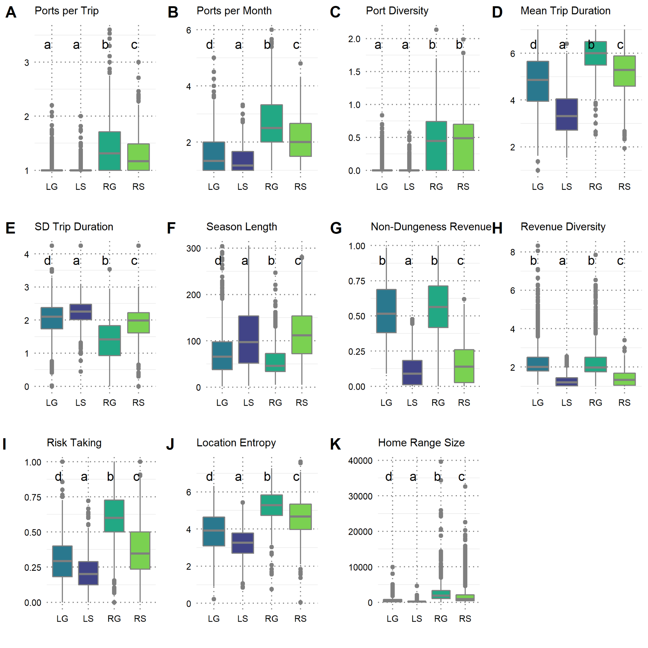

Supplementary Figure 2. Rankings of each behavioral group relative to each variable included in the cluster analysis. Groups with non-significant differences (according to Tukey’s HSD, Supplementary Figure 1) are assigned the same rank.

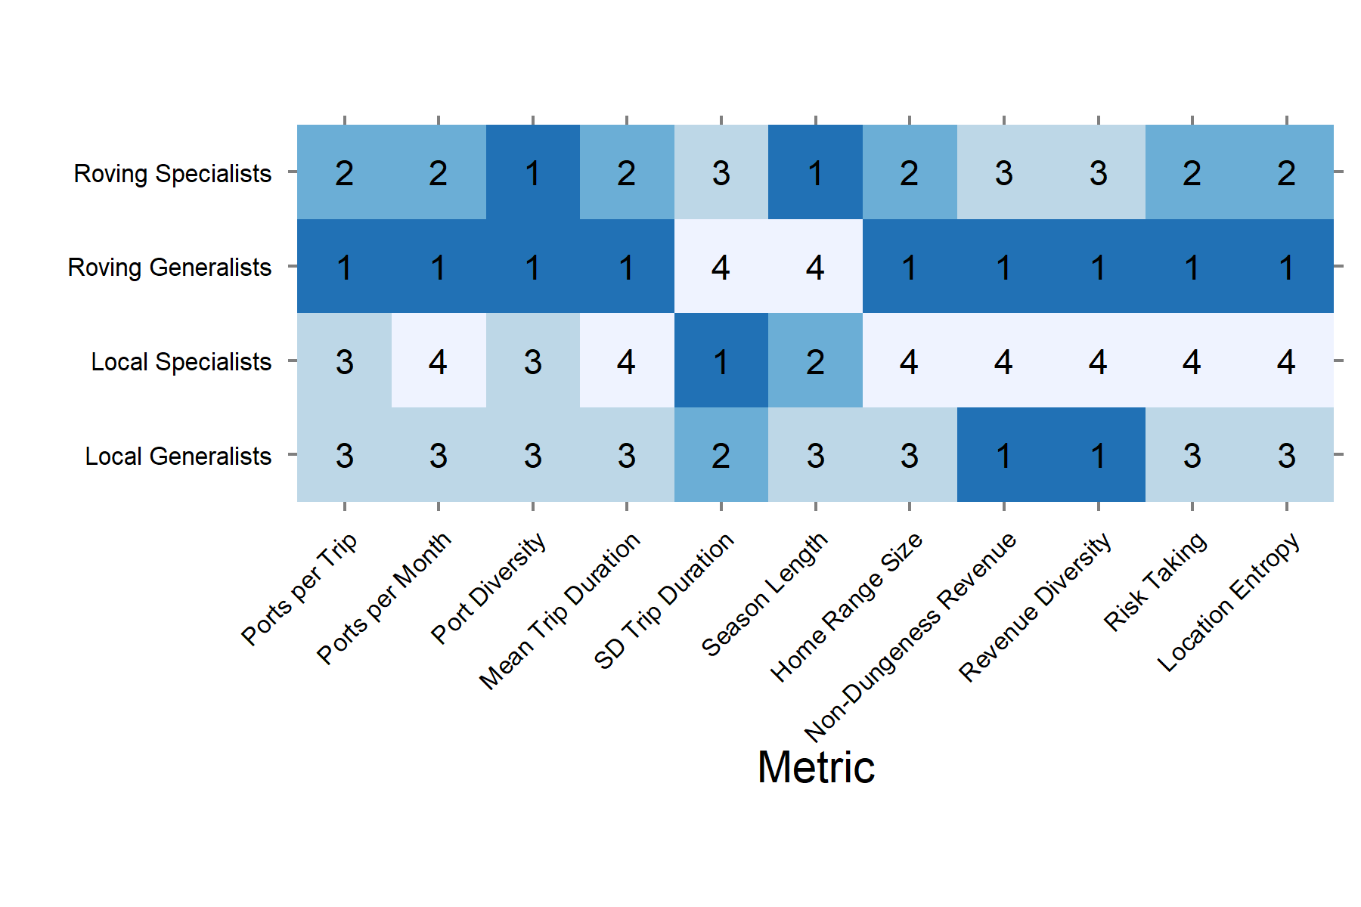

Supplementary Figure 3. Number of vessels in each clustered behavioral group across crab seasons. (a) Number of vessels in each behavioral group in each crab season. Vertical lines delineate the period of the marine heatwave. (b) Mean number of vessels (+/- 1 SD) in each group in heatwave (MHW) versus non-MHW seasons.

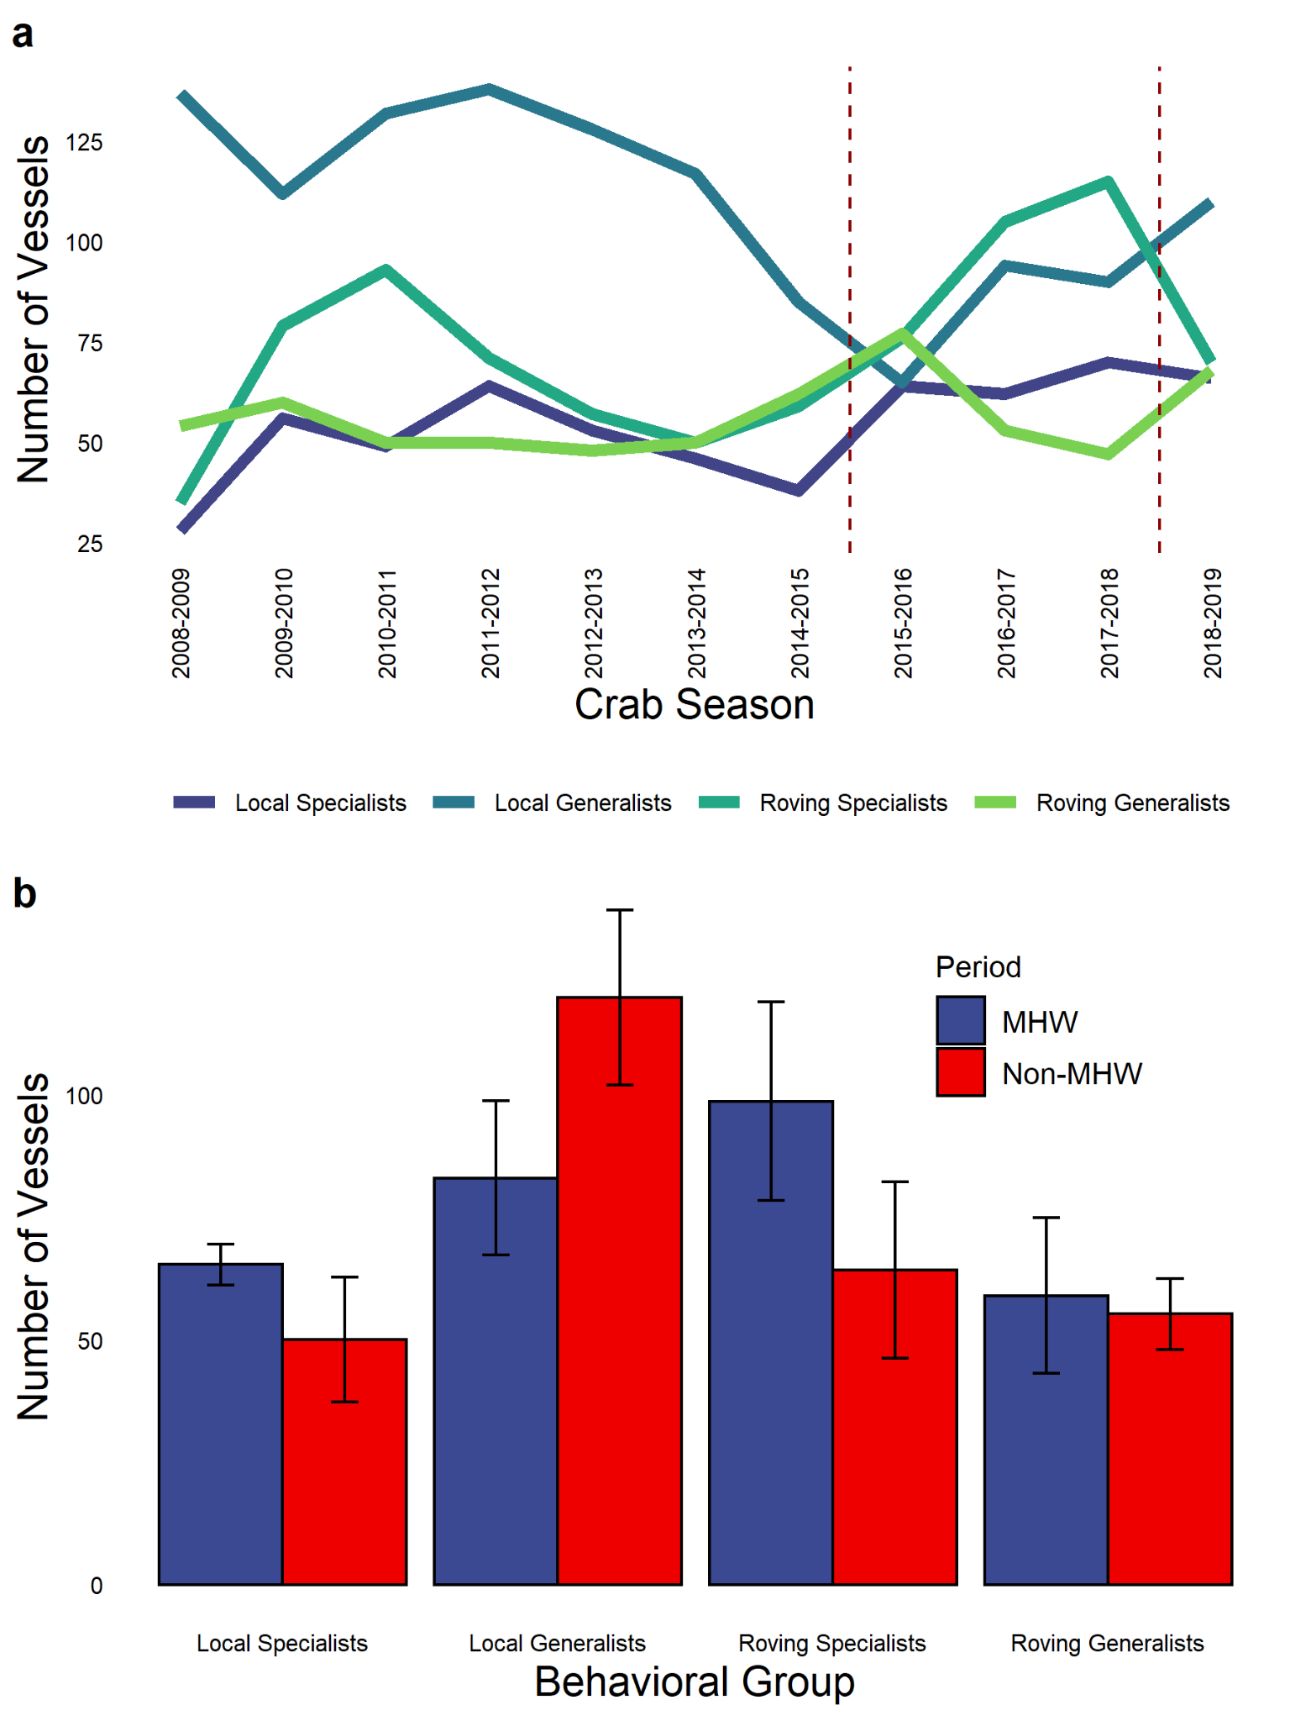

Supplementary Figure 4. Mean profit per day fished for each behavioral group in each week of the crab season, averaged across all seasons. Lines show a loess smooth across weeks for each group.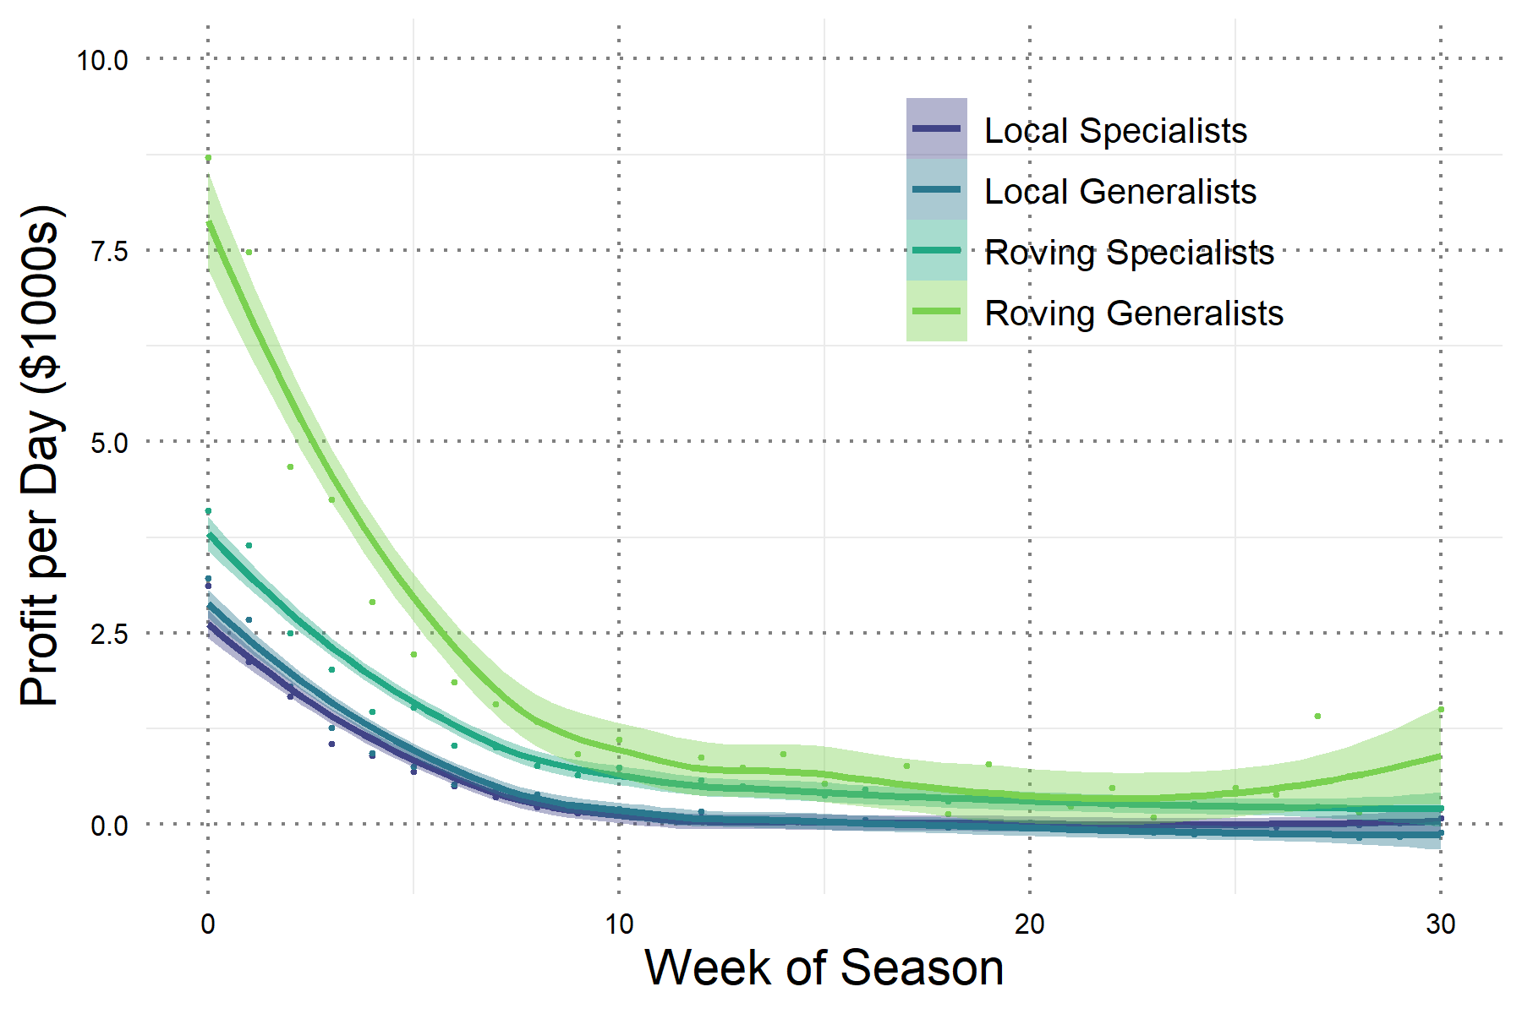

Supplementary Figure 5. Smoothed kernel density distributions of vessel length by behavioral group and crab season. We used vessel registration data from PacFIN to obtain vessel lengths in feet. Vessel lengths were checked for reporting errors, and only the most recent length value was used if a vessel reported multiple different lengths.

